Attachment no. 2 to the Rules of Student Internship at the Faculty of Management, University of Lodz

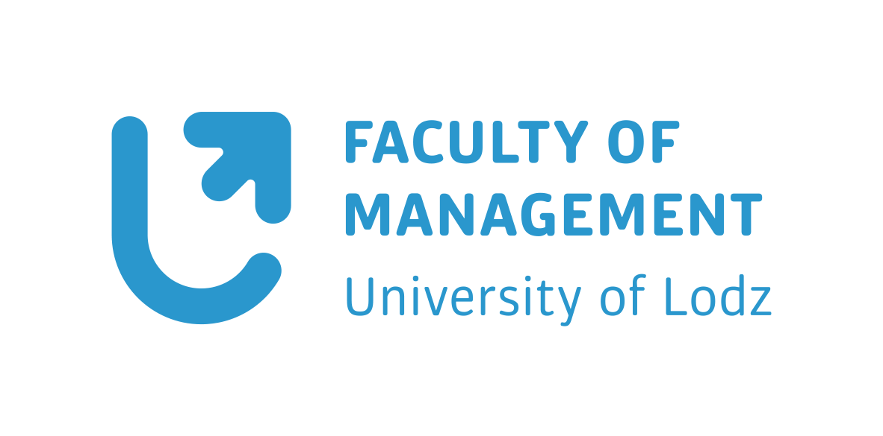

WORK DIARY

STUDENT’S DETAILS
Full name
Student ID no.
Name of the study programme
Mode of studies
(full-time / part-time)

DETAILS OF THE INSTITUTION WHERE THE INTERNSHIP TAKES PLACE
Name or stamp of the organisation
The organisation’s headquarters (with full address)
The actual place of doing the internship if it is different than the above headquarters (e.g. a branch, a department, a shop in a different location)

THE TIME OF INTERNSHIP
The number of full hours of the performed internship
The exact date of commencing the internship
The exact date of ending the internship

THE LIST OF ACTIVITIES (one month on one page)
The date of doing the activities (from – to) | The number of hours | The list of activities | Reference to learning outcomes (please insert a code from the  ‘OUTCOMES’ table below)
Total numer of hours

CONFIRMATIONS OF THE SUPERVISORS RESPONSBILE FOR THE STUDENT IN THE ORGANISATION
Signature and stamp of the Supervisor in the organisation where the internship took place AND of the internship Supervisor at the University of Lodz

THE ASSESSMENT OF THE SUPERVISOR OF THE INTERNSHIP
General assessment of the extent to which the student has achieved the assumed learning outcomes (done by the internship Supervisor at the Faculty of Management, University of Lodz)

THE STUDENT’S CONCLUSIONS / COMMENTS / OPINIONS ABOUT THE COURSE OF THE INTERNSHIP
Student’s signature

OUTCOMES
Code | Learning Outcomes
KNOWLEDGE
PEU_W01 | The Student has the basic knowledge about the methods of managing the relationships between different elements of the organisation as well as the relationship between the organisation and its surroundings.
SKILLS
PEU_U01 | The Student applies the basic theoretical knowledge in management for describing in detail and analysing in practice selected processes and phenomena in the organisation.
PEU_U02 | The Student can perform an analysis of the causes and course of selected processes and phenomena in the organisational environment as well as predict the directions of their changes.
PEU_U03 | The Student has the ability to prepare speeches in the Polish language as well as in a modern foreign language concerning activities they are involved in, using diverse sources of information.
PEU_U04 | The Student has language skills within the discipline of management sciences in accordance with the requirements appropriate for the B2 level of the Common European Framework of Reference for Language Skills.
SOCIAL COMPETENCIES
PEU_K01 | The Student can adequately define the priorities of the performed activities as well as delegate tasks to suitable members of a team.
PEU_K02 | The Student can correctly identify and solve dilemmas connected with their occupation.
PEU_K03 | The Student can actively obtain information and manage their own professional development.

